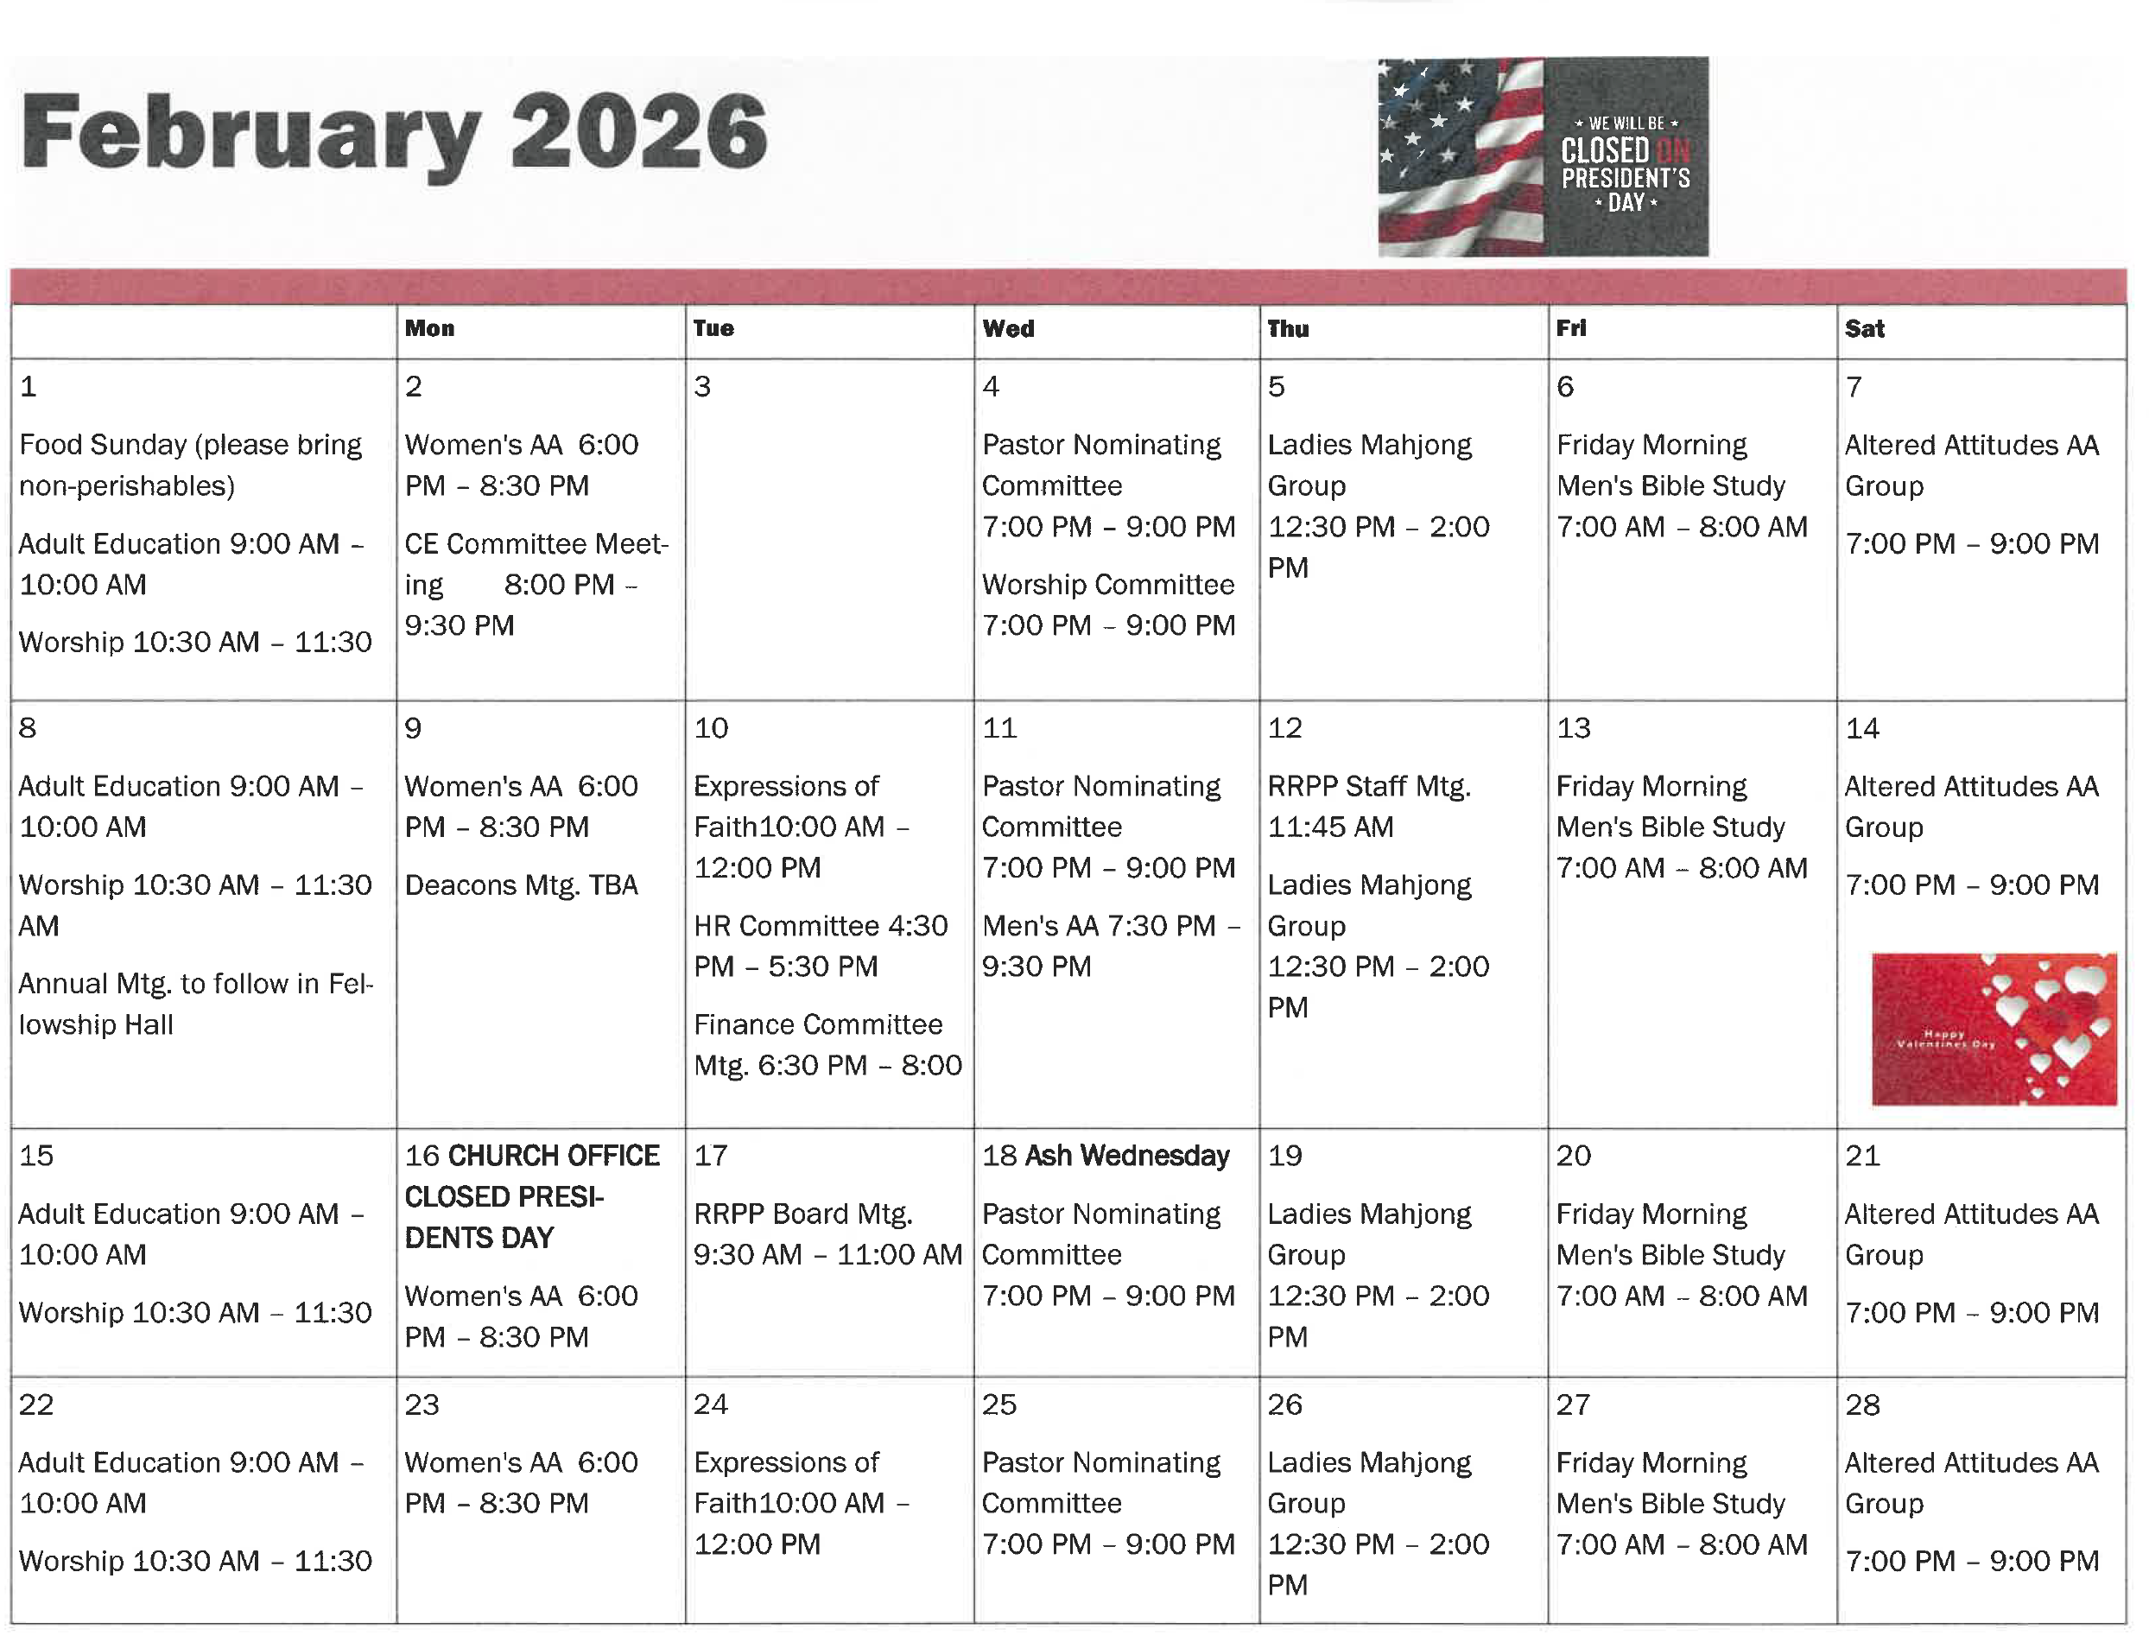
Youth Fellowship will meet on the 22nd 6:00pm to 7:30 pm

