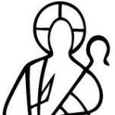
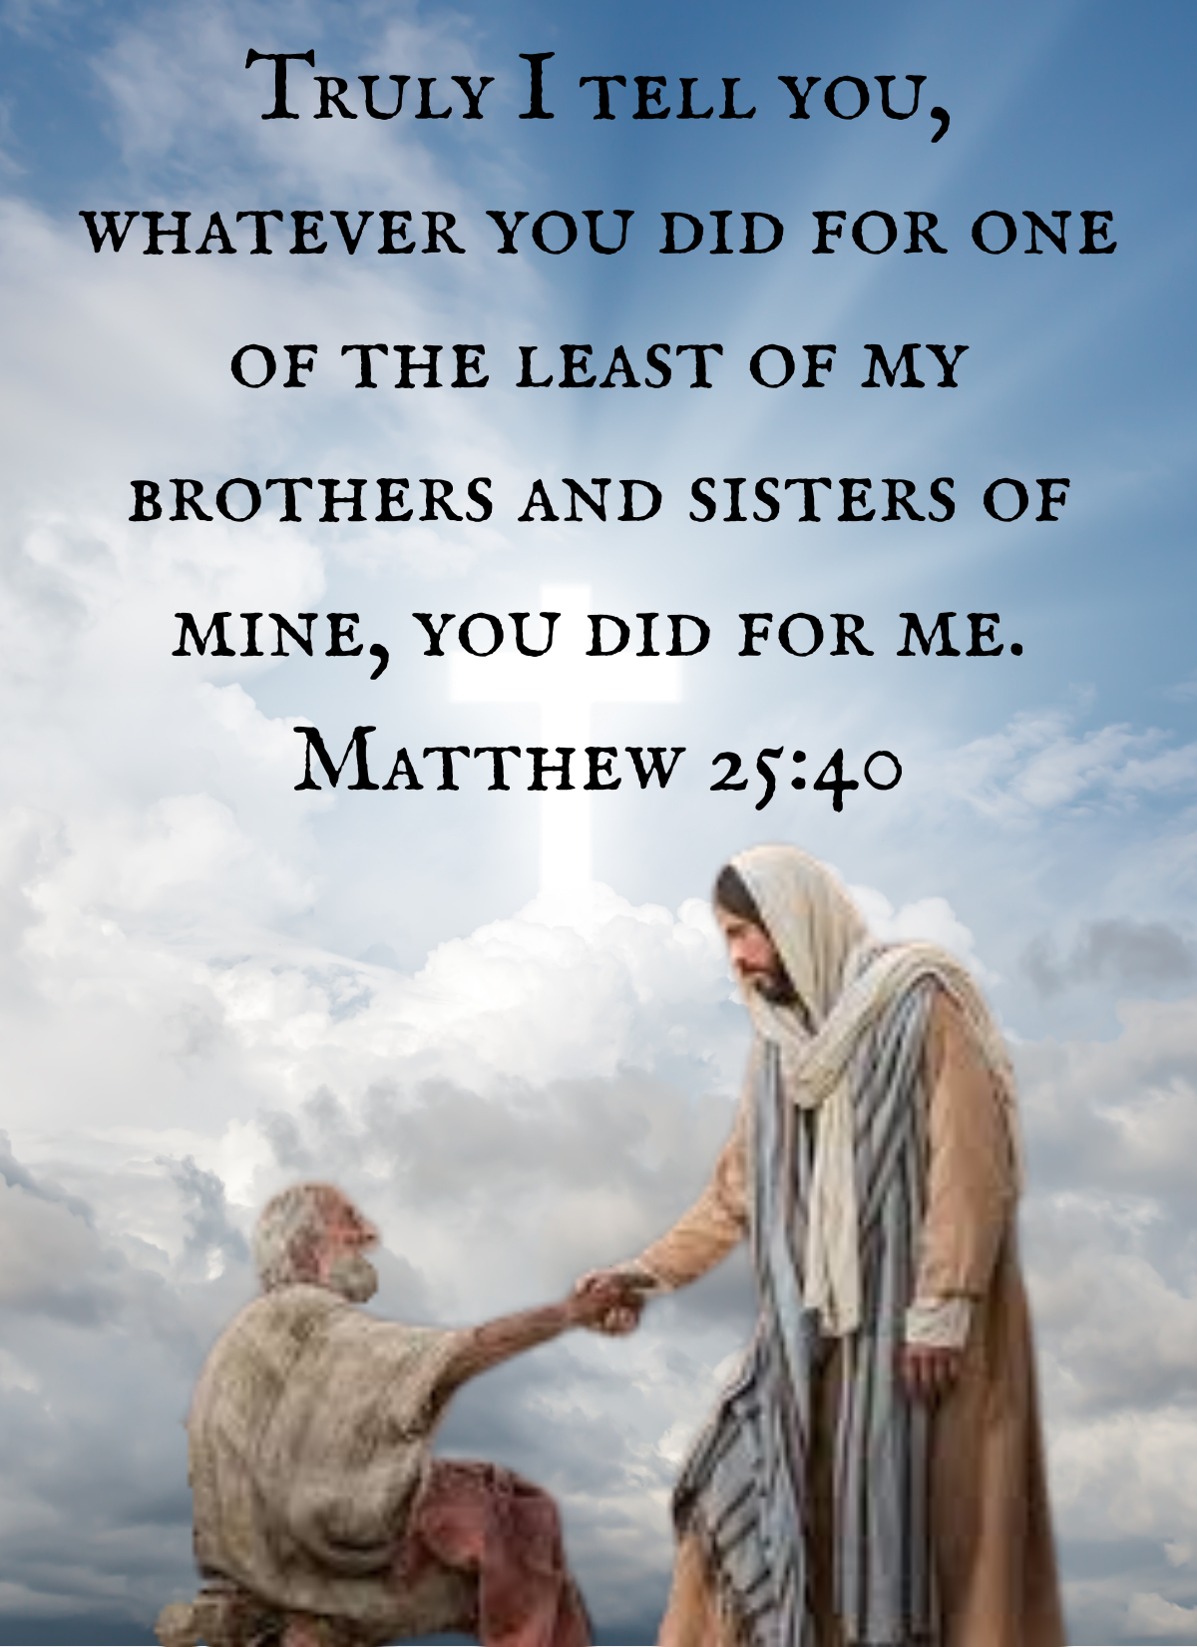

Seventeenth Annual
Alternative Christmas Charity Bazaar
November 23, 2025, and ONLINE through December 30, 2025

Rocky River Presbyterian Church
21750 Detroit Road, Rocky River, Ohio 44116
Frequently Asked Questions?

- What is the “Alternative Christmas” Charity Bazaar? As an “alternative” to mindless gift-giving, “ACCB” is an opportunity to make one or many donations to local, national, and world charities in the name of family or friends. Give your donation as a Christmas gift by completing a gift card and personalize, sign, and include information about your donation. YOU can give these as gifts to your friends, co-workers, and family.
- Why do we have this bazaar? We want to allow you to stop giving the “same old” Christmas gifts. Let’s take the money we usually spend on “obligatory gifts” to friends, office staff, or family (with little meaning) and give gifts to our favorite charities. Don’t we all have enough stuff? This year, buy all of your gifts online at ACCB and encourage your family, friends, and colleagues to do the same.
- What is new? ACCB is in person and online again this year in 3 easy steps. First: Review this catalog. Browse the charities you want to donate to. Second: Print out the order form: include your name and phone number, the charity’s Ministry Code and the Item Code, the number to items you want, and tally the total for your purchase. Third: Make a copy of your order form and your check for your files. Then mail your form and completed check to Rocky River Presbyterian Church or drop it off at the office (you might call first: (440) 333-4888) until Dec 30th.
- When can I “shop”? In a word, now! Donation order forms and checks are due in the church office by Christmas Eve. That way, we can forward the total donations to the charities by the end of the year.
- How many missions/charities are available? Our church has selected 12 local, national, and world non-profit missions, and one fair-trade business for 2025.
- Does Rocky River Presbyterian Church keep part of the money from your donation? No, not one penny. We will tally donation order forms. Then, the church issues one check to each charity for the total amount donated. The church (and not you) is added to the mission’s mailing list. Think of all the junk mail we will have saved you. That is definitely worth something.
- Will my donation be tax-deductible? Yes. Print a copy of your Donation Order Form and check as your receipt. Save it for your tax preparer.

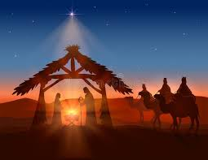
Welcome to the 17th Annual Alternative Christmas Charity Bazaar (ACCB) at Rocky River Presbyterian Church. The ACCB has become a tradition at RRPC to start your holiday shopping. Find that right gift from one of our charities or stocking stuffer to match the interests and passions of everyone on your holiday shopping list.

The ACCB was founded on the premise that sometimes the most thoughtful gift you can give someone is donating to a charity in their honor. This year we celebrate our 17th year.

“No more ugly sweaters”
We are in person and online this year, too, and anticipate a wonderful bazaar. This year, we have 12 charities, and one Fair-Trade business to participate in our ACCB. Most of these organizations have a direct connection to a member or friend of this congregation.

Your support of this event and the gifts you buy from the various charities directly impact people, families, villages, and our world.
100% of your money goes to these deserving charities, and you get
your shopping done with no junk mail, and a tax break.
What could be better?

ACCB is a mission of this church and is guided by the Session’s Mission Committee. The event is coordinated by a dedicated team of people: Chuck Erml, Sara Gresh, Lisa Mach, Barb Johnson and the Mission Committee, Bonnie & Chuck Erickson, Brenda Peterson, Sam Mattocks, Lisa Poole, Melanie Fredrickson and the youth fellowship groups.

Big THANKS to Chloe Mazzillyn Alvis for her beautiful artwork used on this year’s cover and gift cards. A big THANKS to Colleen in the church office for putting the catalog and the gift cards together. Also, a BIG Thank you to Ann Gilbert and Renee for their beautiful gift of music.

May you, your friends, and your family have a wonderful Christmas.
--In Christ, Anne Busher, the Mission Committee, and the ACCB Team
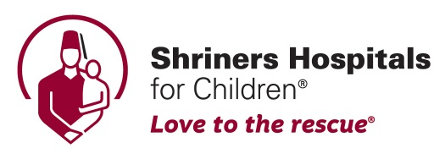

The two locations we are supporting are Dayton, Ohio and Erie, Pennsylvania

Shriners Hospitals for Children has a mission to:
- Provide the highest-quality care to children with neuromuscular-skeletal conditions, burn injuries, and other special healthcare needs within a compassionate, family-centered, and collaborative care environment.
- Provide for the education of physicians and other healthcare professionals.
- Conduct research to discover new knowledge that improves the quality of care and life for children and families.
- This mission is carried out without regard to race, color, creed, sex or sect, disability, national origin, or the ability of a patient or family to pay.

Shriners Hospitals for Children, in Erie, PA, and Dayton, Ohio, provides the highest quality care for a wide range of pediatric orthopedic and neuromuscular-skeletal disorders and diseases and innovative treatment to children with complex skin conditions, burn injuries, and cleft lip and palate. Every member of our staff – from surgeons to therapists to nurses – is focused on providing care that puts the family at the center of the team. In Erie, we were the first healthcare system in the country to develop spinal cord injury rehabilitation centers explicitly designed for children. Our groundbreaking research in Erie and Dayton has led to innovative treatment techniques, providing care that helps children lead a full, active, and healthy life. All donations to this charity will be split between the Dayton, OH, and the Erie, PA Shriner’s Hospitals.
Ministry Code is SHC-Erie or SHC-Dayton
Code | Cost | Description
WAIT | $5 | Book for a child to read while waiting for treatment
READ | $10 | Book for a school-age child to read in the hospital
HUG | $20 | Teddy bear to hug
BOOK | $25 | Book for a teenager to read during hospital
FOOD | $30 | Food, snacks, and treats for teenagers and children following their surgery
ART | $40 | Arts and Crafts Kits for a Teenager
SEAT | $50 | A share of the cost of a car seat to transport a child to and from the hospital
CAR | $100 | The cost of a car seat to transport a child to and from the hospital
The Shriners Hospital makes every effort to use donations as designated.

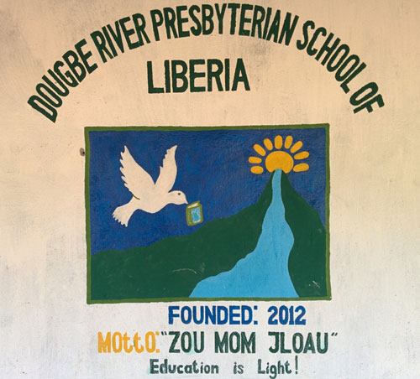

Imagine that there was no school for you… no school within 50 miles. That was what faced a boy who was born in Liberia. He scrapped, worked, and even risked his life, having to leave home to gain an education. Eventually, he arrived in Cleveland, where he finished his education, found work, married, and settled down. Then he told his Presbyterian pastor, ‘We need to build a school in Liberia!’

That’s how it started. The Dougbe (“Doo-BAY”) River Presbyterian School is now a reality. Built on 150 acres of land given to the school by the local leaders and financed entirely by donations—including a donation from RRPC—the Dougbe River Presbyterian School opened its doors to 130 students last year!

Their vision is “to reach out to rural people with education and Christianity. We believe that Liberian young people empowered by education can develop their nation and profoundly reduce poverty. We reach out to Christian and non-Christian people. Our school is open to all children regardless of religion, age, race, gender, or ethnic group. We also stand for peace, unity, reconciliation, honesty and development.”

Ministry Code is DRPS
Code | Cost | Description
PENS | $5 | Pencils and paper for an entire class
RMBD | $10 | A week’s room and board for 4 students
BOOK | $20 | Books for the school’s classrooms
SAL | $50 | A teacher’s salary for a month
GAS | $75 | Fuel for the school’s truck and generator
CON | Your Choice | Donation in an amount of your choice to be used where most needed by Dougbe River Presbyterian School.
Dougbe River Presbyterian School in Liberia makes every effort to use donations as designated. On occasion, donations may be used to meet a similar urgent need.

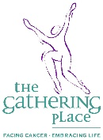

The Gathering Place Westside

Touched by Cancer
The Gathering Place is a local cancer support organization located in Westlake, Ohio. Our mission is to offer a wide variety of free programs and services that address the social, emotional, physical, and spiritual needs of individuals with cancer and their families and friends. The Gathering Place has served 46,890 individuals with more than 371,000 visits. The programs at the Gathering Place serve people with any cancer and their families, including children and teens.
The Gathering Place offers a safe, confidential environment to share your experiences and challenges. We provide access to information on various cancer-related subjects because we believe knowledge is power.
At the Gathering Place, you can interact with others traveling on a similar journey to take advantage of our one-to-one services. Whichever route you choose to take, you can find insight, strength, support, and inspiration.

The Gathering Place has two comprehensive education centers, which include lending libraries with over 2,500 books, CDs, and videos. We offer support groups for all cancer types, cancer-specific groups, age-specific groups, and programs for cancer survivors and caregivers.

The children’s Kidshop, a three-hour family-centered workshop in which family members of all ages can interact and work on crucial coping skills when a family member has cancer, has reached many families.

Ministry Code is WGP
Code | Cost | Description
CAB | $10 | Transportation Costs/Cab Vouchers for one visit to The Gathering Place
TRAN | $25 | Support for Transportation Costs for multiple visits to The Gathering Place
KID | $50 | Support for Kid shop/Children’s Programs
FAM | $75 | Support for Family Counseling
ND | $100 | Contribution to use where most needed
CON | Your Choice | Donation in an amount of your choice to be used where most needed by The Gathering Place
The Gathering Place of the Westside makes every effort to use donations as designated. On occasion, donations may be used to meet a similar urgent need.

Sleep in Heavenly Peace
All children deserve a safe, comfortable place to lay their heads.
Across the US, too many boys and girls go without a bed—or even a pillow—to sleep on. These children end up sleeping on couches, blankets, and even floors, which affects their happiness and health.
Child bed lessness is a national problem, and as a national nonprofit with chapters spread across the country, SHP has provided the solution. They are a volunteer organization that builds beds for kids sleeping on the floor, and there are multiple ways to get involved with the OH-Cuyahoga W chapter.
Sleep in Heavenly Peace® is a group of volunteers dedicated to building, assembling, and delivering top-notch bunk beds to children and families in need. The organization has grown steadily over time, and it’s working on opening more chapters in different states to serve more people.
So many great charities provide clothing, meals, and toys to needy families. But as wonderful as this aid is, few organizations offer suitable beds and bedding to the kids in these families.
At SHP, we fully believe that a bed is a basic need for proper physical, emotional, and mental support for a child. When it was brought to our attention that the need for beds went far beyond our neighborhoods, we stepped up and took the initiative. We're a national organization answering the call to a national problem. If a child needs a bed, we want to ensure they get one. No kid sleeps on the floor in our town®.
Ministry Code is SLEEP
Code | Cost | Description
PIL | $10 | Bed Pillow for one child
SET | $15 | Sheet set for one bed
COLD | $25 | Comforter for one bed
MAT | $100 | One Mattress
BED | $250 | Single Bed
CON | Your Choice | Donation in the amount of your choice to be used where most needed
The Sleep in Heavenly Peace makes every effort to use donations as designated.
On occasion, donations may be used to meet a similar urgent need.

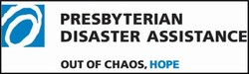

GIVE ACT PRAY
Often, when a disaster happens, families lose everything. By supporting Presbyterian Disaster Assistance (PDA) you help PDA respond quickly to natural or human-caused disasters where the needs are greatest—whether internationally or in the United States.

PDA enables congregations and mission partners of the Presbyterian Church (U.S.A) to witness the healing love of Christ through caring for communities adversely affected by crisis and catastrophic events. PDA is the emergency and refugee program of the Presbyterian Church (U.S.A.) and focuses on the long-term recovery of disaster-impacted communities.

PDA assists in finding shelter, helping displaced people, supporting schools, providing medical assistance, helping the disabled, cleaning and repairing, and supporting agricultural sustainability.

Ministry Code is PDA
Code | Cost | Description
PEN | $15 | A child’s School kit for post-disaster areas containing school supplies: scissors, notebooks, a ruler, crayons, a cloth bag, and pencils and erasers.
RCE | $25 | Family food pack: rice, bread, spaghetti, tomato paste, beans, canned meat, cooking oil, salt, tea, cheese, jam, and milk powder
KIT | $35 | Emergency Household Kit: 2 blankets, 2 plastic mats, 2 mosquito nets, water can, plastic sheet, water purification tablets, and soap.
TOO | $40 | Tool and building supply kit to help homeowners rebuild following a disaster.
DIS | $50 | To assist with the recent Hurricanes in the south, the war in Israel/Palestine and the recent flooding from storms in FL, providing needed medical supplies, food, shelter, and clothing.
CON | Your Choice | Donation in amount of your choice to be used where most needed
Presbyterian Disaster Assistance makes every effort to use donations as designated.
On occasion, donations may be used to meet a similar urgent need.

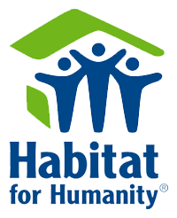

Habitat for Humanity - Cleveland Chapter

Greater Cleveland Habitat for Humanity is a Christian-based organization that develops opportunities for all God’s people to live out their faith. By working in partnership to eliminate substandard housing, we enable families and volunteers to improve lives. We create hope by building homes, strengthening neighborhoods, and reweaving communities.

Through volunteer labor and donations of money and materials, Cleveland Habitat builds and rehabilitates safe, affordable, energy-star-rated homes with the help of Partner families who must put in 500 “sweat equity” hours on their construction site. The Partner Family purchases their home with Habitat's no-interest, non-profit mortgage when the build is complete.

Ministry Code is HFH
Code | Cost | Description
NLS | $5 | A 5-lb box of nails to build a home
DC | $10 | A door chime
BUN | $15 | A bundle of shingles for a house
SWT | $20 | Five wall light switches
BLND | $25 | Window blinds
PNT | $28 | One gallon of latex paint
LIT | $30 | A dining room light fixture
DRL | $40 | An interior door
FRNT | $50 | An exterior door
CFAN | $60 | A ceiling fan
TOOL | $70 | A basic tool set
WALL | $150 | Wall board to finish one room
ROOF | $250 | Share of cost to put on a roof
CON | Your Choice | Donation in amount of your choice to be used where most needed
Habitat for Humanity of Cleveland makes every effort to use donations as designated.
On occasion, donations may be used to meet a similar urgent need.



The Greater Cleveland Food Bank is Northeast Ohio's largest hunger relief organization, providing millions of meals to hungry people in Cuyahoga, Ashtabula, Geauga, Lake, Ashland, and Richland counties.

The Greater Cleveland Food Bank solicits donated food and other products from food manufacturers, wholesalers, retailers, and community groups. We also raise the funds necessary to purchase meals at the best rate to serve as many meals as possible to those in need. Each dollar provides four nutritious meals. Then, we distribute the food to more than 800 partner agencies that serve those struggling with hunger in Northeast Ohio.

In the last fiscal year, the Food Bank made nearly 48 million meals possible to those struggling with hunger in our area. Almost one-third of the people who receive these meals are children under the age of 18, and 15 percent are people over the age of 65. In our area, one in five children is at risk of hunger. Children need healthy food to learn and grow. The meals provided by the Greater Cleveland Food Bank and its member agencies may be the only nutritious food some hungry children receive. Your support will help provide food to help them be successful.

Ministry Code is GCFB
Code | Cost | Description
MEAL | $1 | Provide one nutritious meal for a family of 4
PARTY | $5 | Provide nutritious meals for 20 people
WEEK | $21 | Provide 3 meals a day for 1 week for a family of 4
TG | $25 | All the “fixings” for a big Holiday Dinner for a family of 4
ONE | $30 | Provide one nutritious meal a day for a family of 4 for a month
BAG | $50 | Provider groceries for a family for a week
WOW | $84 | Provide 3 meals a day for 1 month for a family of 4
CON | Your Choice | Donation in amount of your choice to be used where most needed
Greater Cleveland Food Bank makes every effort to use donations as designated.
On occasion, donations may be used to meet a similar urgent need.

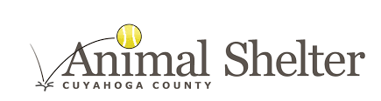

The Cuyahoga County Animal Shelter is a government-regulated agency. Our mission is “to maintain the health of dogs in our care, both mentally and physically, and increase the adoptability of the stray dogs of Cuyahoga County.”

There are 72 kennels on our Main Floor filled with wonderful strays, all from within Cuyahoga County, and they are just waiting to be adopted into forever homes! At any given point, when you stop in, you will find a myriad of breeds, both mixes and purebreds, ranging from two months old to our famous seniors.

We might never know where these pooches were before coming to us, but providing them with a future, permanent home takes a community of help. Your donation today will help to provide much-needed veterinary care for those dogs and puppies that arrive at our shelter sick or injured so that they, too, may have a second chance at a happy life. Your donation will provide a new “leash on life” for countless dogs with heartworms, broken bones, and traumatic wounds. Your gift will allow our dogs to receive medical treatment that we may not have been able to afford to provide for them.

Ministry Code is CCAS
Code | Cost | Description
RAB | $5 | Rabies shot
PUP | $7 | Bag of puppy food
CHEW | $12 | Big Chew toy for a dog
VAC | $25 | Vaccines for a dog
WRM | $40 | De-worming treatment for five dogs
NUET | $50 | Neuter surgery for a dog
SPAY | $65 | Spay surgery for a dog
VET | $75 | Visit to a veterinarian
TRET | $100 | Heartworm Treatment for 1 dog for 1 month
CON | Your Choice | Donation in amount of your choice to be used where most needed
Cuyahoga County Animal Shelter makes every effort to use donations as designated. On occasion, donations may be used to meet a similar urgent need.
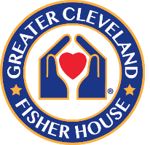

Greater Cleveland Fisher House
Helping Military Families
What is a Fisher House?

The Greater Cleveland Fisher House is part of the VA Northeast Ohio Healthcare System. The system delivers comprehensive health care and social services for Veterans at locations across Northeast Ohio. The Louis Stokes Cleveland VA Medical Center is the system’s hub, and operates more than 20 national and regional referral services for Veterans.

Comprising two 16-suite homes, the Greater Cleveland Fisher House provides a “home away from home” for families of military and Veterans receiving care from the Cleveland VA Medical Center and area hospitals. Fisher House guest suites each have a private bedroom and bath. They also have a shared common kitchen, laundry area, dining room, living room, library, and toys for children. The homes are professionally furnished and decorated and are wheelchair accessible. All at NO COST to the Veteran or their families.
These families, who live at least 50 miles from the treatment facility, stay at one of the two warm and inviting Fisher Houses. The shared common spaces allow families to talk with one another and know they are not alone.

The Greater Cleveland Fisher House opened its doors to its first guests in 2019.

Ministry Code is FISH
Item Code | Cost | Description
YUM | $5 | Kids baking supplies to make something yummy to take to Daddy or Mommy
FUN | $10 | Games and books for the family room
SOFT | $15 | Soft pillow for a bed
DRY | $25 | Two (2) umbrellas for families to use when walking from the house to the hospital
WARM | $50 | A warm quilt for one bed or two (2) seasonal throw blankets
THANKS | ANY $$ | Want to give a little more to say thank you for your service?

The Fisher House makes every effort to use donations as designated. On occasion, donations
may be used to meet a similar urgent need

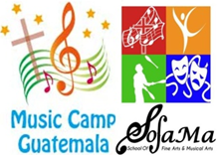
Music Camp Guatemala
Impacting Eternity through Music

SUMMER MUSIC CAMP is a one-week camp and SOFAMA (School of Fine Arts & Musical Arts) is an after-school program both for kids ages 10-19 who are from high-risk situations and orphanages. These two programs provide intensive training in music and discipleship.

Not only do kids learn to read music and play wind instruments, they are trained to be followers of Jesus. A dynamic teaching style that includes team building and games, emphasizes the lesson of the day. Group music making develops social skills and promote unity.

The SOFAMA program offers small group and individual attention from a caring, dedicated music teacher who provides a supportive relationship and consistent foundation for them as they navigate the trauma of disintegrated families and mitigate the temptation to find “family” in the gangs.

The Summer Music Camp mixes the groups and includes kids from other music programs and churches widen their horizons and deepens their experience in prayer and worship. All of camp is done with priority and emphasis of doing ALL for God’s glory.

Ministry Code is McG
Code | Cost | Description
1LUN | $5 | One student lunch at McG camp
1WSOF | $10 | Student sponsorship for one week at SOFAMA
5LUN | $25 | Five student lunches at McG Summer Camp
2WSOF | $30 | One student sponsorship for 2 weeks at SOFAMA
1MSOF | $55 | One student sponsorship for one month at SOFAMA
MCGS | $75 | Donation to McG Summer Camp scholarship fund
CC | ??? | Donation of your choice
Full sponsorship for: SOFAMA $660; Summer Music Camp $750.
Music Camp Guatemala makes every effort to use donations as designated.

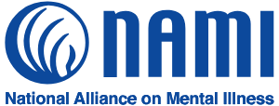
National Alliance on Mental Illness Greater Cleveland

For more than 40 years, NAMI Greater Cleveland has leveled rocky terrain. The kind of terrain that surfaces when someone is diagnosed with a mental health condition. This unsettling land often leads to
shame, fear, and uncertainty exist with the absence of knowledge and the prevalence of stigma.

In comes NAMI GC with its FREE mental health education and support programs for individuals living with a mental health diagnosis (peers), their family members, and the community at large. NAMI GC’s
programs empower everyone affected by mental health conditions to achieve a better quality of life by providing them with mutual support, practical information, referral, advocacy, and educational resources. In 2022, NAMI GC met the needs of more than 9,000 people. Help NAMI GC smooth the path for people affected by mental illness.

Your contribution allows peers and their family members to access the necessary resources to improve their lives.

Ministry Code is NAMI
Code | Cost | Description
HELP | $10 | Support peers and family members calling our Helpline by underwriting the cost of a resource packet.
FAM | $26 | Provide resource materials for a family member in  our 12-week Family-to-Family class where he/she will  learn strategies for handling crisis and relapse, as  well as communication and advocacy techniques.
OWN | $30 | Help change attitudes and stereotypes about mental  illness by funding the stipend given to a peer when  sharing his/her personal experience with the community  through an In Our Own Voice presentation.
CON | Your Choice | Write in any amount for one of NAMI GC’s education classes, support groups, or its Helpline.
NAMI makes every effort to use donations as designated. On occasion, donations may be used to meet a similar urgent need.

We encourage you to visit the


The One World Shop has been a loyal contributor to the Alternative Christmas Charity Bazaar event annually. Their mission is to educate and engage our community on Fair Trade and related global social justice issues by providing various educational outreach programs and a vibrant marketplace for handmade artisan goods.

In 1973, a group at Lakewood Presbyterian Church was motivated after reading the publication “The Alternative Christmas Catalog”, which was the effort of one Methodist layperson sharing his frustration with what had happened in our culture to the celebration of Christmas. As an alternative, he proposed using the criteria of “person-affirming, life-supporting” in our decisions about celebrating Christmas. One way of doing this would be to “affirm and support” persons living in poverty who have no market for what they produce. By purchasing gifts from such “alternative trade” sources and offering a fair price, one empowers these people to support their families, have a sense of self-dignity, and not depend on hand-outs.

For five years, the Lakewood group held “alternative Christmas fairs” across Cuyahoga County until 1979 when the opportunity to move permanently into a storefront arose, and so One World Shop was established.

A visit to the store at 1932 Detroit Rd. in Rocky River will delight you with its wide variety of truly unique and beautiful items from around the world. Your purchases from the store will also give you another opportunity to help those in need.

For your reference, here is an example of a completed
Order Form which you can print off to help you.

Ministry Codes for Charities
County Shelter = CCAS | Dougbe = DRPS | Fisher House = FISH | Shriners Hosp Erie, PA = SHC-Erie
Shriners Hosp Dayton, OH = SHC-Dayton | Cle Food Bank = GCFB | NAMI = NAMI | Gathering Place = WGP
Sleep I Heavenly Peace = Peace | Presbyterian Disaster =PDA | Habitat for Humanity = HFH | Music Camp Guatemala = McG

“Online ACCB”
is as easy as “1-2-3”

1. Review the catalog; browse the charities.

2. Print out the order form and fill out the charity’s Ministry Code and items that you like. Please include your full name at the top of the form with a phone number, the Ministry code, the Item Code, the number to items you want, and the tally the total cost for your purchase. Print out gift cards for your recipients or use your own.

3. Make a copy of your order form and your check for your files. Then drop off or mail your order form and check to Rocky River Presbyterian Church.

